# Assignment 3A on Loops and Graphics

**(5 marks)** Write a program that lets the user enter a positive whole-dollar amount and then prints out how many bills of each denomination should be taken to make that amount, using the fewest number of bills and coins.

If the number of bills needed is more than 1, it should print the plural form of the word, e.g. “bills”

If the number of bills needed is 1, it should print the singular form, e.g. “loonie”, not “loonies”

If the number of bills needed is 0, it should not print that bill or coin at all.

Example:

Enter a dollar amount: 491

You should take:

4 $100 bills

1 $50 bill

2 $20 bills

1 loonie

Note that it did not print “0 $10 bills”, “0 $5 bills” or “0 toonies”.

**(10 marks)** Use a for-loop and Python graphics to generate this picture:

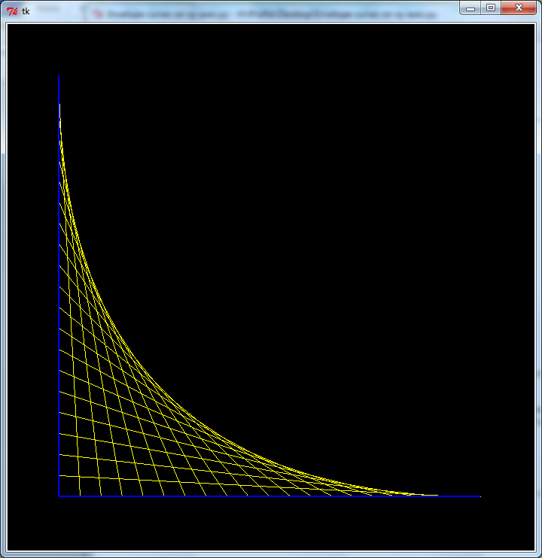

Here is the basic algorithm:

* Pick an (x, y) value for the blue corner
* Pick a length for the blue lines
* Draw a blue vertical line and a horizontal line of that length, starting from the corner.
* Pick how many yellow lines you want to draw
* Use a formula to calculate how far apart the end-points of the yellow lines will have to be in order to fit that many lines before the blue line ends.
* Use a for-loop to draw as many yellow lines as you picked, spaced as far apart as the formula determined.

**(10 marks)** Invent a text-based Python game that uses a while loop, similar to Rock Paper Scissors or the Dice Game we saw in class. The more creative and intricate the game, the higher your mark. It can be a known game like RPS, or a game you made up.

Requirements:

* The while loop must have a compound Boolean condition
* When the game ends, the program should print a summary of the results, depending on what stopped the game (e.g. a certain score was reached, or the user quit.)

# Marking scheme

|  |  |
| --- | --- |
| **Problem 1: Cash counting** | **Marks** |
| Prints the correct amounts of each bill and coin | 3 |
| Skips the printing of bills and coins that are not used | 1 |
| Uses plural and singular forms correctly | 1 |
|  | **5** |
| **Problem 2: String art** |  |
| Uses a variable for the number of lines | 1 |
| Uses a formula to calculate the gap size before the loop begins | 2 |
| Uses gap size inside the loop to calculate starting and ending points | 2 |
| Draws the correct picture | 2 |
|  | **7** |
| **Problem 3: Game** |  |
| While loop with compound Boolean condition | 2 |
| Prints a summary | 1 |
| Creativity and detail | 7 |
|  | **10** |
| Readability of your code (comments & spacing) | **3** |
|  |  |
| **TOTAL** | **25** |